Aleksandr Haskin, Flutist
The Pearl, Porto Arabia 14, 1310. Doha 5825, Qatar
aleksandr.haskin@gmail.com +97466078509

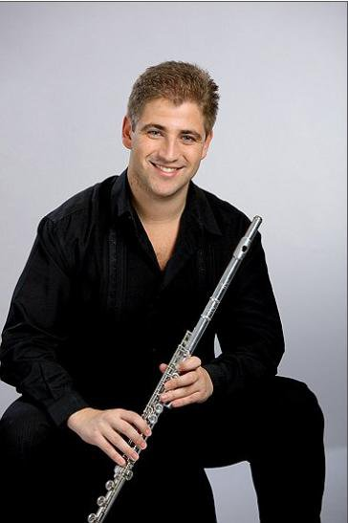

Born in Minsk, Belarus.

Education:

MA (2007), and PhD (2010) degrees from Moscow Tchaikovsky Conservatory, where he studied flute performance with Alexander Golyshev.
One year of scholarship-based study with Ransom Wilson at Yale University School of Music (US).

Additional training:

Performed in flute master classes led by Aurele Nicolet, Andras Adorjan, Andrea Lieberknecht, Ransom Wilson, Michael Parloff, Paul Meisen, William Bennett, Pierre-Yves Artaud, Jean Ferrandis, Felix Renggli, Patti Monson, Gabriele Fumet, Elzbieta Gajewska, Bruno Meier, Yuriy Doljikov, Roswitha Staege, Helen Bledsoe, Hans-Joahim Fuss, Benedec Chalog, and Wilbert Hazelzet.

Also performed in chamber music master classes led by Krzystof Penderecki, Boris Berman, Jerome Pernod, Jerome Dukro, Richard Killmer, Humbert Lucarelli, Frank Morelli, Joan Panetti, William Purvis, and the Tokyo String Quartet.

Orchestral and Solo performances:

BURKART Artist and Representative (www.burkart.com)

Solo concerts abroad including Kennedy Center in Washington DC; Merkin Hall in
New York City; Nexus Concert Hall at Chanel, Tokyo, Japan; Forbidden City Concert Hall in Beijing, China.
Currently, Aleksandr is the Co-Principal flutist of Qatar Philharmonic Orchestra.

Former orchestral engagements:
Soloist piccoloist of the Bolshoi Theatre Orchestra, Moscow (2007-2008)
Principal flutist of the Moscow Gennady Rozdestvensky Symphony Orchestra (2007-2008)
Collaborations and locations:

Aleksandr has performed under the baton of Lorin Maazel, Krzysztof Penderecki, Gerd Albrecht, Gennady Rozdestvensky, Dmitri Kitajenko.
Performances as an orchestral musician at Carnegie Hall, Boston Symphony Hall, Kennedy Center, Theatre Champs Elysee, Teatro alla Scala, Teatro Massimo de Palermo, Bolshoi Theatre and Great Hall of The Moscow Tchaikovsky Conservatory.

Participated in various music festivals in US, England, Germany, Netherlands, Poland, Qatar, Iran, Russia, and Belarus.
Aleksandr has also ventured into cross-disciplinary collaborations involving music, choreography, and Multimedia Design, notably at the recent Tasmeem International Arts and Design Conference held at the Virginia Commonwealth University, Qatar Campus.

Teaching:
Qatar Music Academy and American School of Doha (2012-present)
Undergraduate level teaching at Yale University (2006-2007)
Conducted master classes and open lessons in the USA (Carnegie-Mellon University, Pittsburgh; Colburn School and University of South California, Los Angeles; California State University Dominguez Hills, Carson; Levine School of Music, Washington DC; Missouri State University, Springfield), Normal University of Shanghai, China; Moscow, Russia; Belarus; Qatar; and Iran.
Competitions:

Alexander & Buono International Flute Competition, New York, USA (2010)
1st Prize

Young Concert Artists International Music Audition, New York, USA (2009)
1st Prize
De Lorenzo Flute Competition, Viggiano, Italy (2009) 3rd Prize

Penderecki Flute Competition in Cracow, Poland (2008)
2nd Prize (1st Prize non-adjudged)

Shostakovich Chamber Music Competition, Moscow, Russia (2008)
3rd Prize

Woolsey Concerto Competition, Yale University, USA (2007):
Prize winner.

International Contemporary Chamber Music Competition in Cracow, Poland:
1st Prize in the duo category (2005)
1st Prize in the trio category (2005)
2nd Prize in the duo category (2004)

7th International Music Competition in Astana, Kazakhstan (2004):
Grand Prix.

Grants:
The Guzik Foundation, Moscow, Russia, 2004
The Russian Performing Arts Foundation Scholarship, 2005, 2008

Concert Reviews:

http://communities.washingtontimes.com/neighborhood/curtain-up/2011/jan/27/aleksander-haskin-dc-debut/

http://www.washingtonpost.com/wp-dyn/content/article/2011/01/25/AR2011012506104.html

http://www.huffingtonpost.com/jim-luce/what-joy-aleksandr-haskin_1_b_825498.html

