CLARA BIERMASZ, PIANO:
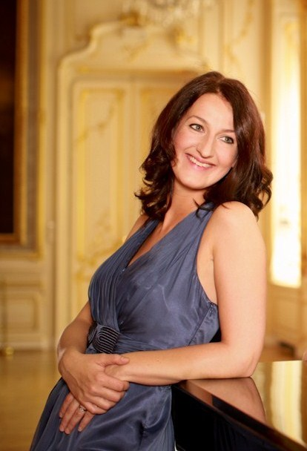
Photo: Julia Wesely
Clara Biermasz was born into an artistic family, from the Netherlands. Despite beginning to learn the violin at the age of four, it was the piano that captured her interest and remained her main focus since the age of eleven.
In 1999 she began her studies at the Academy of Arts in Utrecht, in the Netherlands, studying with both Alexander Warenberg and Klara Würtz. In 2004, she received her bachelor’s degree then moved to Budapest, Hungary to continue her studies; taking on a two year Postgraduate course at the Ferenc Liszt Academy, studying with both Balázs Szokolay and Balázs Reti. After finishing she continued her studies in Vienna, with Michael Hruby. She is currently graduating from the Universität für Musik und Darstellende Kunst Wien (MA).
“…ein außergewöhnliches Talent mit großen technischen Fähigkeiten…” Internationale Föderation der Chopin-Gesellschaften und der Internationalen Chopin-Gesellschaft in Wien (2011)
Throughout her career, Clara has won several prizes in national and international music competitions. In 1996 she won the first prize (VSB prize) and the Youth Jury prize, in the Princess Christina competition, in the Netherlands. In July 2008, together with the cellist Adam Javorkai, she received first prize in the subdivision chamber music prize, as well as the first prize overall ‘Primo Premio Assoluto’ in the international music competition ‘Premio Citta di Padova’ in Padua, Italy. In December 2008 she was prize-winner in the 18th International Chamber Music Competition in Thessaloniki, Greece.
Clara performed in Vredenburg Utrecht, de Doelen Rotterdam, Muziekcentrum Frits Philips Eindhoven, Kasteel Duivenvoorde, Kasteel Geldrop, the Hermitage in Amsterdam, Museum of Fine Arts Budapest, National Theatre in Miskolc (Hungary), Richard Strauss Residenz in Vienna, Teatro Olimpico Vicenza, Palazzo Albrizzi in Venice, Palazzo Zacco-Armeni in Padua (Italy), Dutch Embassy in Cairo (Egypt). Besides she played in Denmark and France and at prestigious festivals like the Cello Festival Dordrecht, the Chopin Festival in Gaming and the Settimane musicali al Teatro Olimpico. Moreover, Clara performed for several radio and television programs.
Clara has a great passion for performing chamber music and regularly performs in duo sonata works, piano trios, piano quartets and is a Lied-accompanist. Since 2000 she has regularly performed with the Dutch mezzo-soprano Karin Strobos, and since 2005 she has formed regular duo partnerships with the renowned Hungarian cellist Ádám Jávorkai and the Dutch cellist Sanne Bijker.
Clara is grateful for all the wonderful insight she has received from exhilarating master-classes from artists such as Angelica May, Jan Wijn, Alan Weiss, Itamar Golan, Martijn van den Hoek, Jean-Claude Vandeneynden, Istvan Gulyas, Oleg Koshelev and Gergely Bogányi.
She is also thankful for all the financial support she has been fortunate to receive, from sponsors and scholarships, from the following foundations: Stichting A.F.V.O.M.S., Willem Mengelberg Fonds, Prins Bernhard Cultuurfonds (Jonge Musici Fonds), Stichting Niemeijer Fonds, Stichting Vreedefonds and Fonds voor de Geld -en Effectenhandel.
“…Her beautifully clear narrative sound let one just forget the worries of everyday life…” Wiener Chopin-Blätter (2012)
“…Her professionalism, musicality, flexibility in following the musical lines of her partners impressed me very much…” G.B.Rigon, conductor (2011)
“…However she touches the keys, always is that masterly undertone recognizable. Diligently she made the works of
Liszt and Chopin sing. Liszt, how could it be otherwise: she is graduated from the Liszt Academy in Budapest and brought a
warm-blooded tribute to this composer…” Het witte weekblad (2011)
“…Two exceptional talents with brilliant technical and refined interpretative skills…”
Padova Cultura (2008) about the Duo Ádám Jávorkai & Clara Biermasz
“…matchless virtuosity…”Eelder Courant (2008)

