NADEZDA TOKAREVA

(Violin)

Laureate of International Violin Competitions,

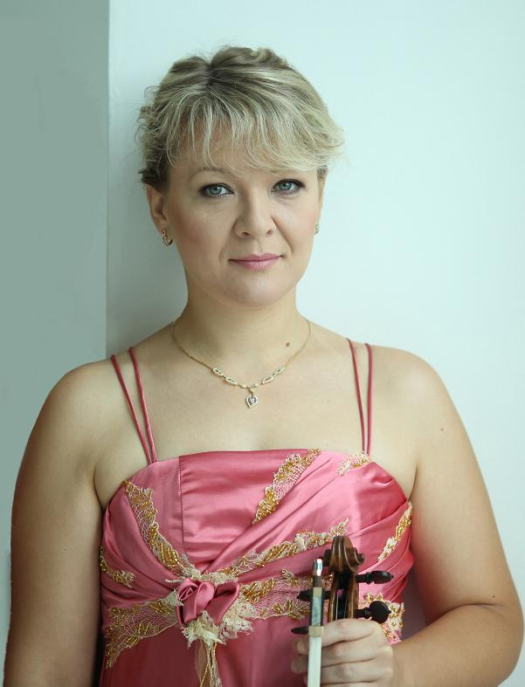
“… If only one example could show the stellar stat of last weekend’s Winterfest concert, it would be this: Virtuosic violinist Nadezda Tokareva soloist in Saturday’s superb Moscow State Radio Symphony Orchestra Concert… Tokareva was a standout in her taxing solo, her expressive violin shifting effortlessly from the muscular to the ineffably ender…”
“The Daytona Beach News-Journal”, by Laura Stewart

“Maestro Kornienko got wondrous help from his violin concerto soloist, Nadezda Tokareva, whose goddess-like technical competence matched her statuesque presence in a dazzling, iridescent green, pleated, full-length gown. She tossed off the stops and trills, the soaring melodies as if they were mere trifles; in the lower registers she achieved a polish and suavity that summoned up memories of David Oistrakh; her command of the first movement’s cadenza clamped the audience in a jaw-dropped stone silence, marveling at the brilliance of her technique…They stood shouting "Bravo!" at the end.”
“Telegram & Gazette Reviewer”, by John Zeugner

BIOGRAPHY

Russian – Slovenian violinist Nadezda Tokareva was born in 1977 in Penza, Russia into a family of musicians. She began to study violin at the age of five. In 1993, Nadezda entered the Penza music college (class of L. S. Romadina) and graduated in three years with honors. Nadezda was very successful during her years of study in Penza and won several competitions in Russia (Penza, Astrakhan, Nizhny Novgorod and Vologda).
Nadezda Tokareva entered the Tchaikovsky Moscow State Conservatory in 1996 to study in the class of People’s Artist of the USSR, Professor Edward Grach.

Nadezda became a laureate of a number of International violin competitions during her academic career:

• Third prize at VII International competition of violinists in Germany (Kloster – Schontal, 1997)
• Grand Prix at I International competition "The Violin of the North" (Yakutsk, 1997)
• First prize at II International Yampolsky Competition (Penza, 1999)
• Special prize at XII International Tchaikovsky Competition (Moscow, 2002)
• Special prize at the International Competition M. Long - J. Thibaud (Paris, 2002)
• Second prize at the I Paganini competition (Moscow, 2003)
• Winner of international festival «April spring» (North Korea, 2006).

Nadezda has also participated in a number of prestigious international master classes and music festivals, including: international master courses Мonti Azzurri Аcademy (Italy,1998) and Keshet Eilon (Israel, 1999) and international musical festivals in Оhrid, Macedonia; "Guadix Classica", Spain; international musical festivals in Tours, Nice, and Eu, France; "Stars of Planet", Yalta, Ukraine; "Kharkov`s Assambleas", Ukraine; "Daytona Winterfest", the USA; IV Gabala International Music Festival, Azerbaijan.

Since 1997 beginning as a student, Nadezda became a member of and worked in the Moscow Philharmonic Society as the artist of the chamber orchestra “Moscovia” and then as the soloist-violinist.
Nadezda Tokoreva has performed in the principal Moscow concert halls, including the Great and Small Halls of the Moscow Conservatory, the Tchaikovsky Hall, and the Svetlanov and Chamber Halls of the International House of Music. Her concert schedule includes venues in more than 30 countries including Russia, the United States, countries of Western and Eastern Europe, Israel, Turkey, China and Japan.
Throughout her professional career, she has performed with numerous famous Russian and foreign symphonic and chamber orchestras and has toured twice as soloist and concertmaster with the Moscow State Radio Symphony orchestra in the United States in 2004 and 2010.

The diversity and richness of her repertoire capture her audiences. She has the ability to adapt her style to accommodate the demands of a broad range of musical repertoire from baroque to contemporary composers. Nadezda Tokareva is the author of a number of violin transcriptions and arrangements.
Over the past several concert seasons Nadezda has participated in a number of interesting concert programs including tango, jazz and folk. Nadezda Tokareva is the first violinist in Russia to perform publicly the “Russian Concerto” by Edward Lalo and the world premier in France of the 2nd Sonata for Violin and Piano by Valery Arzoumanov (dedicated to Nadezda Tokareva) and several other works.
A good deal of her concert activity revolves around the Russian State Concert Company “Commonwealth”, with which Nadezda Tokareva has collaborated closely for more then 10 years. During Russia’s Culture Days, she has presented and still presents on the art of the Russian violin and constantly receives high consideration from music critics as well as the enthusiastic delight of her concert audiences.
Nadezda Tokareva’s performance style is characterized by bright individuality, formidable technical skills, interpretive power and magnificent sound, the ability to fully expose the composer’s spirit and to most clearly present the essence of the composition to the public.

Since 2002 Nadezda Tokareva has been an associate professor of the Tchaikovsky Moscow State conservatory. Her pedagogical life is very active:
In August 2004 she was invited to teach in XII Summer school "New Names" UNESCO (Suzdal, Russia).
In December 2006 – teacher of Mobile Academy of Arts (international project of the Russian Fund of culture, Russia, Yekaterinburg.)
From 2006 to 2009 – professor of Kurashiki Sakyo University, Japan.
Sinse 2011 - an associate professor of the Maimonides State Classical Academy, Moscow

Some students of her class became laureates of the international competitions. Nadezda Tokareva has also served on several international competition juries.

Since 2011 Nadezda Tokareva lives and works in Slovenia. The Republic of Slovenia recognized Nadezda's artistic merits by granting her Slovenian citizenship under the accelerated procedure.

