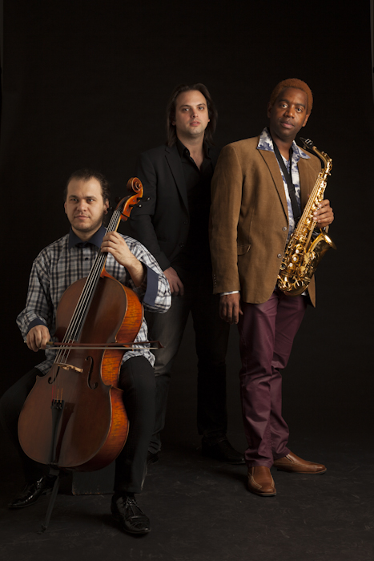

Formed in 2013 the genre-defying Bohemian Trio is a contemporary music ensemble based in New York City. Its founding members: Yosvany Terry saxophone & chékere, Rubin Kodheli, cello and Orlando Alonso, piano are in demand performers as well as accomplished composers

With unique instrumentation and emphasis on improvisation, the trio’s focus is to premier new musical works from a broad range of genres: classical, Afro-Cuban, Tango, Rock, Jazz & Electronic. Drawing on their own compositions and those of other post modern classical composers they are developing a new sound that echoes the melodies of Europe and South America, as well as the rhythms of the African Diaspora in the Americas. Their concert debut was in February of 2013 at the Music of Now Marathon at Symphony Space in New York City.

The name Bohemian best captures the artistic spirit of the members of the trio; non-traditional, adventurous, romantic, idealist, and inspiring.

