EBADUL HUQ SHAIKAT

House: 72, Road:15/A, Dhanmandi R/A, Dhaka, Bangladesh

Mobile: +8801746429999// +880191139324

sitarmelody@yahoo.com //shaikat@chhayanaut.org

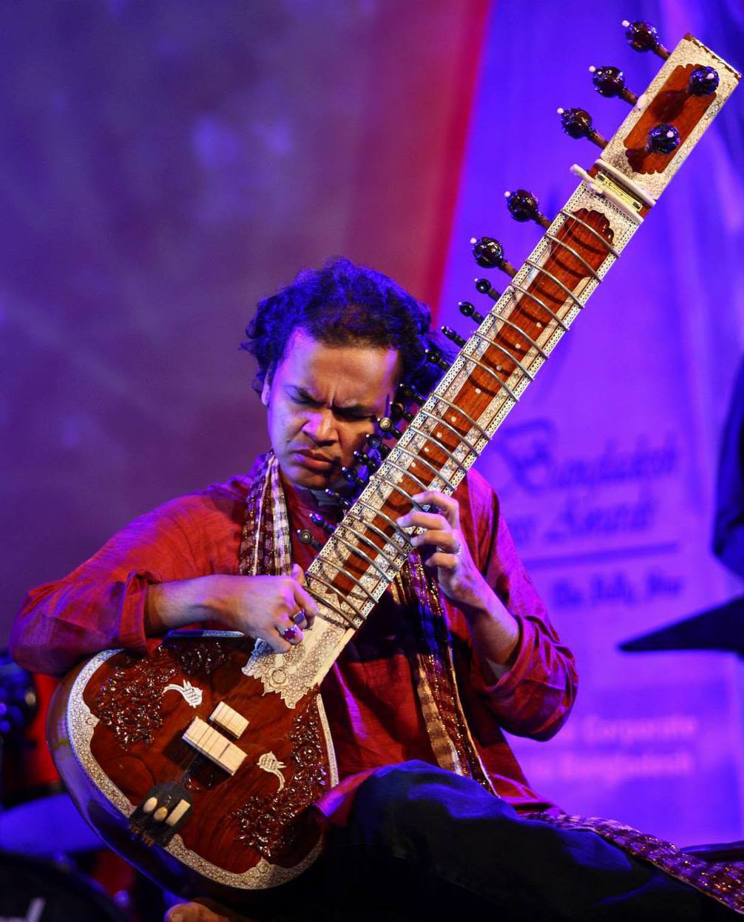

Ebadul Huq Shaikat is a disciple of world renowned Sitar Maestro Pt. Kartik Seshadri. Shaikat started his musical journey through learning Tabla from Sri: Madan Giopal Das. In 1993 Shaikat started learning Sitar from Ustad Khurshid Khan at Chhayanaut Sangeet Vidyayatan, Dhaka, Bangladesh and continued till 1995.
In 1995 Shaikat went India for Higher musical Study with a ICCR Scholarship at Rabindra Bharati University, Kolkata. Shaikat successfully completed his Honours and Masters in Instrumental Music (sitar) from Rabindra Bharati University, Kolkata,India.
At Kolkata Shaikat started learning Sitar from Let, Pt. Ajay Sinha Roy of Myhar Gharana. After death of Pt.Ajay Sinha Roy Shaikat started taking lessons from Sitar Maestro Late Pt. Deepak Choudhury. At present he is a disciple of world renowned Sitar Maestro Pt. Kartik Seshadri.
Shaikat has a personal approach of Maihar tradition, with very precise feeling of Shruti, and a deep spiritual touch. His esthetical understanding gives him a very personal sound, and his pallet of colors is balanced with technicality as well as sobriety. Shaikat has been pursuing his dream intensely and has established himself as one of the talented upcoming artist of the younger generation of performing musician through, Television and several stage performances. Apart from being a performer, he is also a dedicated teacher.
Shaikat has already Shaikat gives private tuitions and conducts workshops. He is always very keen in giving a good understanding of the spiritual and emotional nuances that can blossom in the contact to Indian classical music.
Shaikat has performed different concerts both in Bangladesh and India like Bengal-Sra Musical Festival, Chhayanaut Music conference, Laksyapar Music Conference, Zakir Husain College Delhi, RBU Kolkata and many other concerts.His musical expression expresses deep romanticism, peace, love and devotion and that is always appreciated, by music lover people. At present Shaikat is working as a sitar teacher at Chhayanaut Sangeet Vidyayatan Bangladesh.

