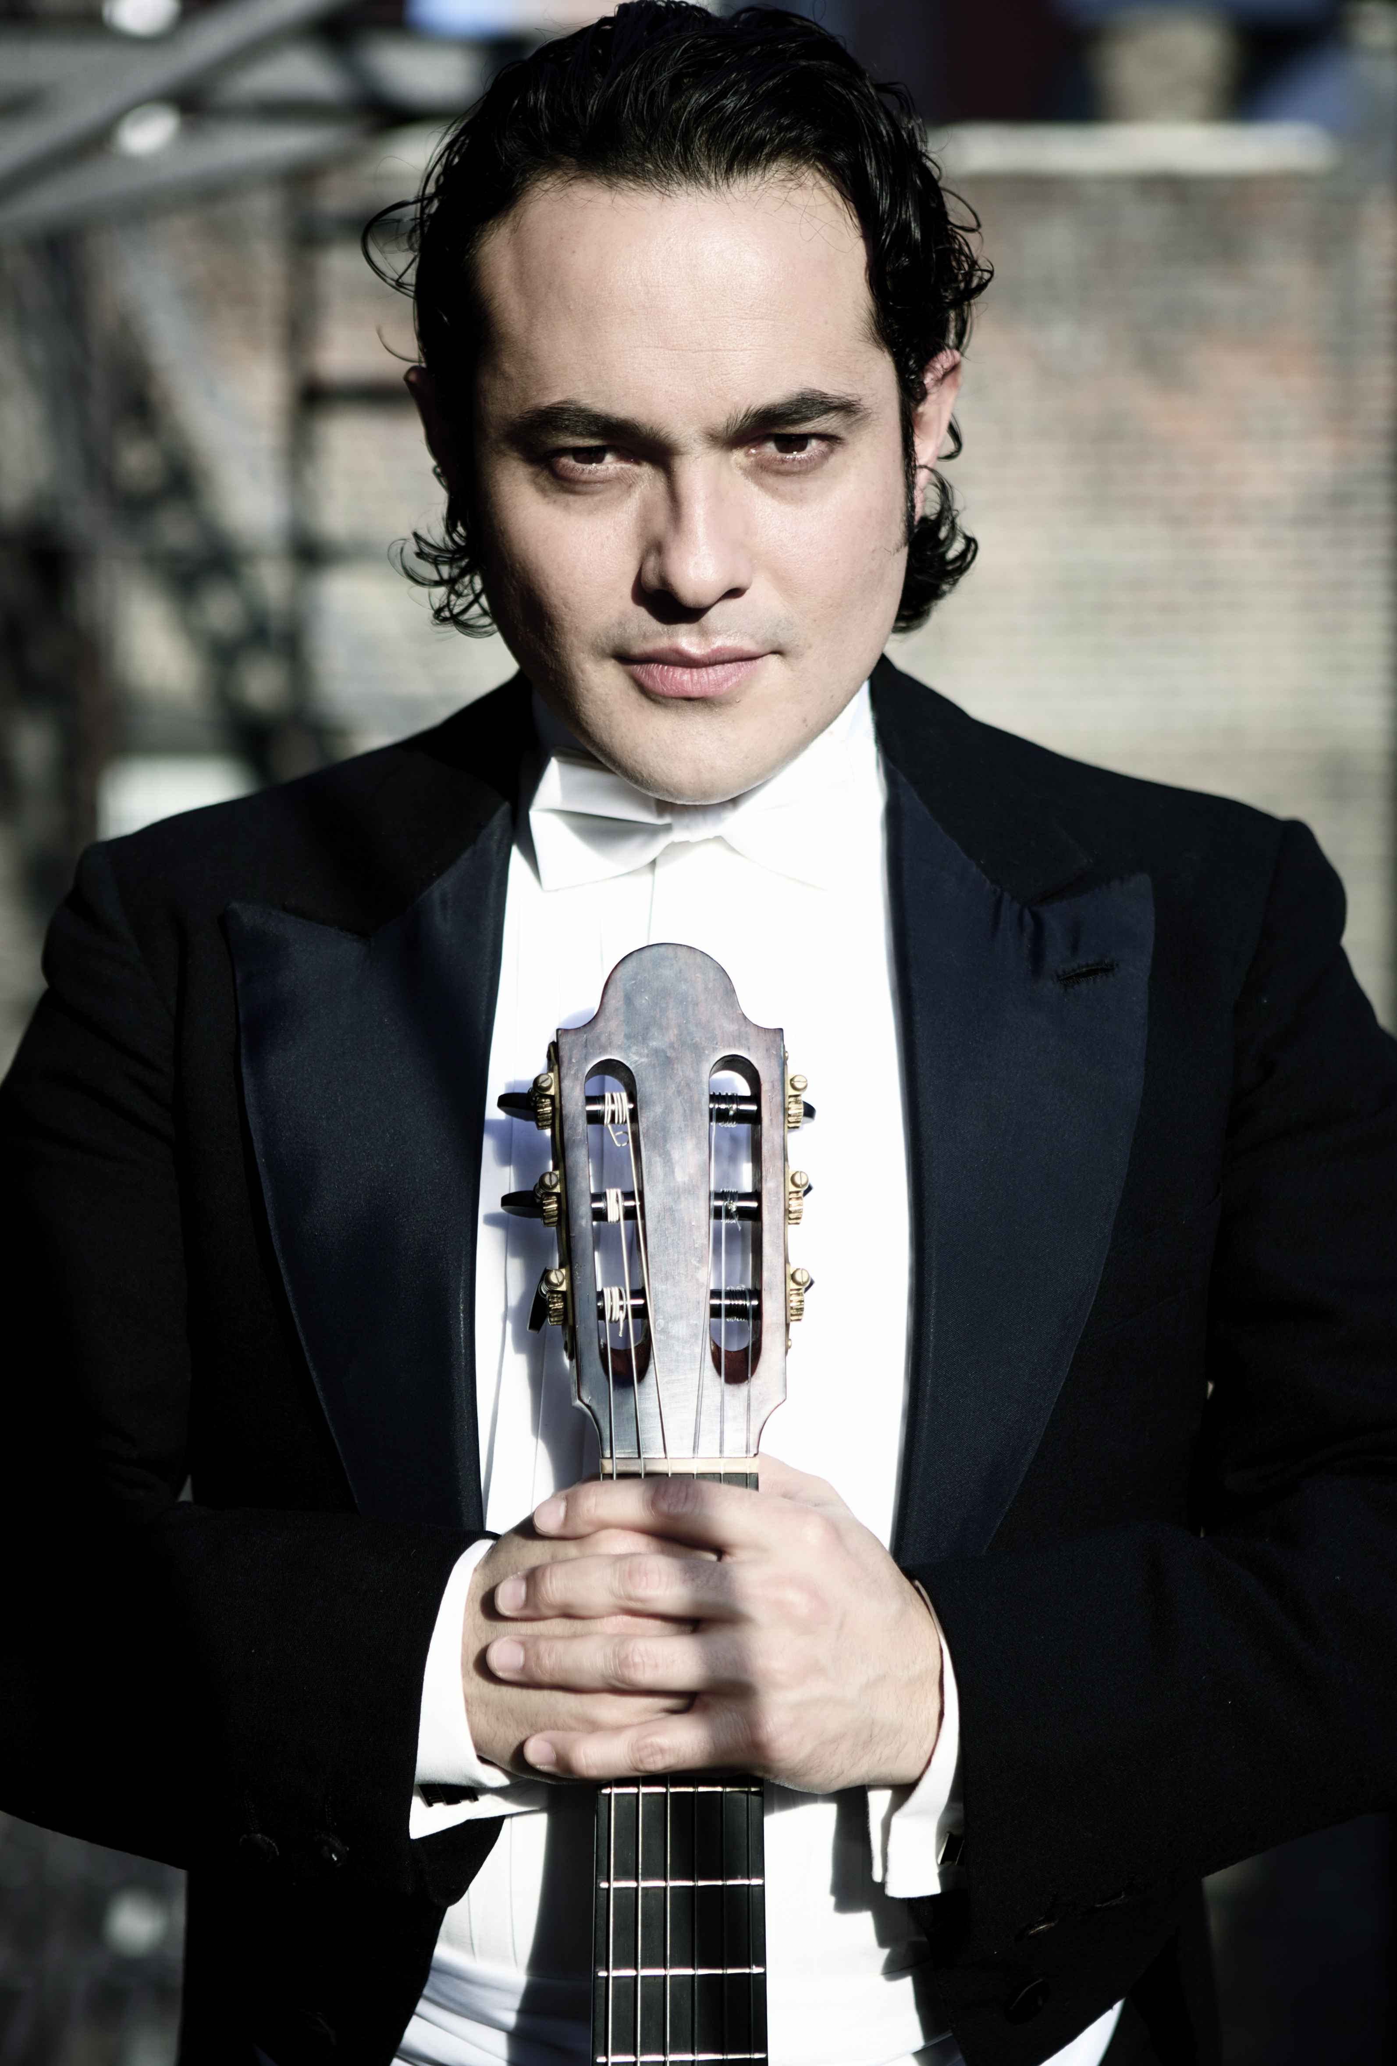After capturing the First Prize at the Artist International Competition In New York, Nilko Andreas Guarin, has quickly established himself as one of the leading classical guitarists. He has performed in over fifteen countries around the globe on such prestigious stages as New York’s Carnegie Hall, Wildthurn Castle in Germany, The Strathmore Hall In Bethesda, Jay Priztker Pavilion in Chicago, The Smithsonian and BID concert series in Washington DC, Adolfo Mejia Theater in Cartagena, Museum of fine arts in Houston TX, with Pianist Harold Martina, Teatro Municipal in Rio de Janeiro, Brazil, Palacio Foz in Portugal and Shenzhen Symphony Hall in China. Recipient of many international awards including the “Recognition award” by the city of New York for his contributions to the Arts. Mr.Guarin has appeared as soloist with the Shenzhen Symphonic orchestraof China , The Azlo Orchestra, the New York Chamber Ensemble, Tactus contemporary ensemble, 20/21 emsemble the “Mariuccia Iacovino” Symphony Orchestra of Brazil among others.
NILKO ANDREAS GUARIN, Concert Guitarist
He has participated in renowned international festivals in Rio de Janeiro, Brazil, The Long Island Guitar Festival in NY, “Wildthurn” in Munich, Germany The Mannes guitar seminar and “Moment Musicaux” in Normandie, France, and has worked with prominent composers including Alba Potes, “Prix de Rome” winner Juan Pablo Carreno, Reinaldo Moya and Ricardo Llorca and with conductors such as Bartholomeus Van de Velde, Vince Lee, Michel Adelson, Laurine Fox, and Alondra de la Parra. Nilko Andreas has appeared with RCN TV, Fox News, Cuny TV, HJUT and “W” Radio in Colombia and WQXR in New York. He recorded with Multiplatinum Artist Mariah Carey. He is also working on releasing a CD of Colombian music that features the world première recordings of “Pequena Suite” op. 80 no. 1 by G. Uribe Holguin. He also premiered at Carnegie Hall “Tukanos” Concerto for guitar and orchestra by Alba Potes to be recorded in 2013. He is invited annually to perform for her majesty The Queen Sofia of Spain at the Queen Sofia Spanish Institute Gala.
“Nilko Andreas is a gifted Musician, and a great performer”.- Rafael Puyana, Paris 2009
He began playing Cello at the age of seven at the National Conservatory of Music in Bogota, he holds a BM and a Master of Music degree from The Manhattan school of Music in NY where he graduated “Magna Cum Laude” on Classical Guitar, Composition and orchestral conducting.
After performing the Villa-lobos Guitar concerto at Carnegie Hall in NY the Backstage New York considered Nilko Andreas as an “electrifying performer for his powerful stage presence and spontaneity that grows, irresistible”. An accomplished educator, Nilko Andreas has given master classes and conferences on Classical Colombian Music at distinguished universities such as Columbia University, the Mannes College of Music in New York, NYU, The Berkley School of Music, the French Alliance in Cartagena and the Eafit University In Colombia. he has great interest for the composers of Latin America, constantly commissioning and premiering new works.
As a composer, Nilko Andreas has written music for independent films, theatre and solo artists. His score for silent film “Pancho Villa’s Revenge” was celebrated at the world-renowned Flaherty Film Seminar. In the year 2005, his collaboration with award-winning theatre group Artificio, in Federico García Lorca’s “The Butterfly’s Evil Spell”, won him several honors, awards and rave reviews.
Nilko Andreas is the co-founder of la Cumbiamba eneye, an ensemble that performs Colombian traditional music from the Atlantic and Pacific coasts, cumbiamba was created in the year 2000 with the purpose of preserve, and teach Colombian heritage around the world. (www.lacumbiambany.com).
Upcoming engagements include Concerto de Aranjuez by J. Rodrigo in Shenzhen, China with the Shenzhen Symphony Orchestra under Mto. Bartholomeus-Henri Van de Velde, European tour with Austrian Violist Firmian Lermer during the 2013 season and concerts in Brazil with Violinist Ricardo Amado and soprano Angelica de la Riva, and solo concerts in Brazil, Colombia, Austria, Switzerland as well as a Concert at Carnegie Hall with the Azlo Orchestra in NYC on November 27 2013. www.nilkoandreas.com

Upcoming engagements include Concerto de Aranjuez by J. Rodrigo in Shenzhen, China with the Shenzhen Symphony Orchestra under Mto. Bartholomeus-Henri Van de Velde, European tour with Austrian Violist Firmian Lermer during the 2013 season and concerts in Brazil with Violinist Ricardo Amado and soprano Angelica de la Riva, and solo concerts in Brazil, Colombia, Austria, Switzerland as well as a Concert at Carnegie Hall with the Azlo Orchestra in NYC on November 27 2013. www.nilkoandreas.com

